Feasibility Study on Establishing Child Day Care Centers

H&M Women for Women Project
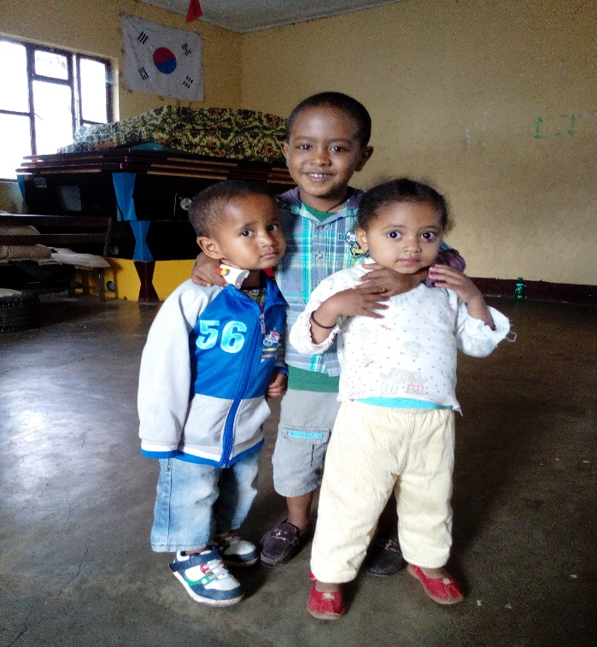
Addis Ababa, Ethiopia
October 2017
Executive Summary
CARE Ethiopia and Mission for Community Development Program (MCDP) are running a project entitled ‘Women for Women (W4W): Creating opportunities for Women in Enterprise Development in Addis Ababa, Ethiopia’. The project has put indicators as a means of gauging its performance. One of the expected intermediate results was 50 women-led social service providers to deliver adequate services to women workers and entrepreneurs. As one of the strategies, establishing child day care center (DCC) was conceived.
Ethiopia has promulgated an Early Childhood Care and Education (ECCE) policy framework (2010) having four basic pillars. The policy framework was endorsed and ratified by Ministry of Education, Ministry of Women and Children Affairs and Ministry of Health. The Day Care Centre is under the ECCE pillar of Health and Early Stimulation Program (Prenatal to 3+ years). The program offers integrated services to all children from prenatal to 3+ years of age and their parents; it also includes a developmental stimulation component.
In order to generate practical inputs for DCC, a feasibility study was initiated. The objective of the feasibility study was to generate practical inputs for CARE Ethiopia and its implementing partner (MCDP) in supporting the targeted low income entrepreneur women to establish child day care centers in three sub-cities (Lideta, Kirkos and Arada) of Addis Ababa.
The feasibility study followed a pragmatic/mixed approach of collecting both quantitative and qualitative data. Data were collected from primary and secondary sources using document analysis, interviews, FGDs, questionnaires, observations and case reports. Two woredas were considered in each sub city purposively as they are the operational areas of MCDP. These were: Arada (woreda 5 and 10), Kirkos (woreda 9 and 10) and Lideta (woreda 5 and 7).
115 respondents were contacted in the study, among these, 63 (54.8%) of the respondents were women beneficiaries representing community of each selected woreda. The qualitative data were transcribed and analyzed using narration and content analysis technique whereas the quantitative data were analyzed using frequency count and percentage.
The feasibility study revealed that out of a total of 5,000 beneficiary women targeted under W4W project, there were 2,656 (53.12%) low income women who are being benefited from Village Saving and Loan Association (VSLA) package. 80.9% of the women are below the age of 45 years which shows that most of the beneficiaries are in the category of productive and reproductive age. Likewise, as to the education level, 69.4% of the beneficiaries are literate (basic reading and writing to diploma and above). There were also 1,376 children of the beneficiaries across all the three woredas who are under the age of 4 years, who are the potential clients for the DCC service.
Though there is standard for DCC, from stakeholder respondents except health and private DCC owners, most (92.3%) of the respondents were not aware of its existence. It has also been found that Food, Medicine and Health Care Administration and Control Authority (FMHACAA) is the regulatory organ for child DCC and yet there is a confusion on the roles and responsibilities of the three key signatories.FMHACAA has clearly stated the standards for child DCC including the geographical location; design and construction of the center; play area; bed rooms and other facilities. Additionally, it clearly stated the age, educational background (training) and number of care givers and the ratio of care givers to children (There shall be 1 care giver for 4 children who are aged less than 29 months, for 8 children between 30 and 35 months of age, and 10 children who are 3 years and above).
All the FGD discussants and interviewees unanimously agreed on the need of DCC and it is the interest of the local community and they affirmed their interest to be involved in DCC initiative as well. Center based DCC is more preferred than the home based due to the required standard as well as safety and health related issues though it is very difficult to get space for the center based DCC. Schools were the only avenues to initiate center based DCC. As to the paying capacity, the minimum proposed fee was 300.00 and the maximum was 600.00 birr per month per child which makes the average 450.00 birr. With regard to the training center, there is no as such established GO, NGO or privately owned training center or institute in the target sub cities. One training center was found at regional level, which provides a two months training on child care and related issues. Additionally, the government sector offices have shown interest, commitment and areas of expertise to give trainings in their areas of specialization.
In sustaining the DCC, stated alterative businesses that can be integrated with the day care service includes kids’ corner, provision of supplementary foods and drinks, income out of traditional handicrafts and stationary sale were mentioned to be viable sources of income to contribute for the sustainability.
Finally, the feasibility study came up with the following key recommendations to be considered at various levels by the responsibly body:
Consultative Meetings and Awareness Creation: organize consultative meetings and awareness raising sessions for sector offices from higher to lower structure (Ministries, Bureaus, sub cities and woredas)
DCC Approach: Center Based Approach is the most feasible one in the present scenario considering the standards, requirements on space and safety issues.
Technical Support and Supervision: Key actors need to be identified and given the full authority and power to supervise and give technical support for the DCC.
Resource Mobilization and Partnership: Government has to push forward in earmarking a budget; mobilizing NGOs, CBOs, FBO and the target communities to get synergy, partnership and collaboration.
Working Area /Availing Free Space: Sector offices need to be committed to secure free spaces or integrate with the existing schools, GO offices and sign MoU (Memorandum of understanding).

Leadership and Management: The leadership and management of DCC need some skills. Thus, low income women should be selected seriously with defined criterion and the government has to provide rigorous support including provision of necessary training.

